Zasam Retest

Issues with the email input validation

test@example.com - leading white spaces allowed

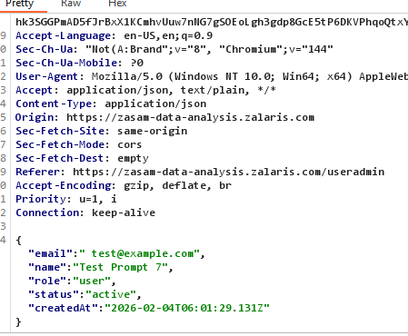

test@example.invalidtld - non existent TLD accepted

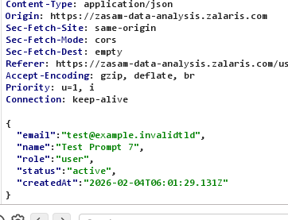

test@exam--ple.com - invalid hyphen Usage

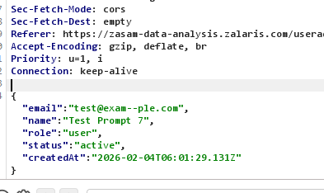

-test@example.com - starts with special character

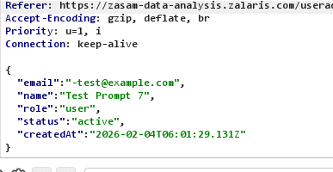

test-@example.com first part ends with special character

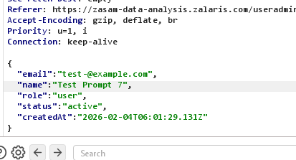

_test@example.com - starts with underscore Policy Violation

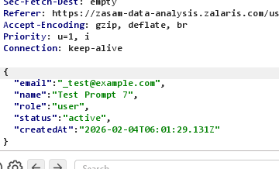

test_@example.com - ends with underscore policy violation

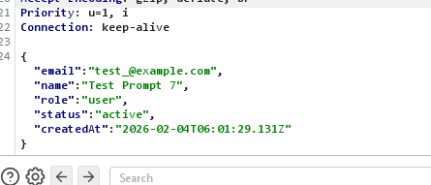

-_@example.com - local part contains only special characters

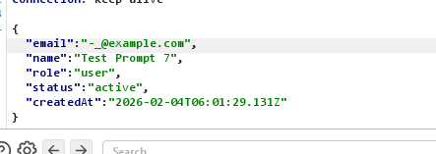

aaaaaaaaaaaaaaaaaaaaaaaaaaaaaaaaaaaaaaaaaaaaaaaaaaaaaaaaaaaaaaaa@example.com - local part exceeds 64 character Limit

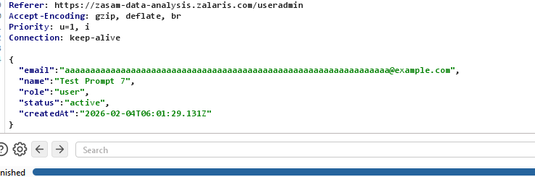

test@tempmail.com - disposable email service

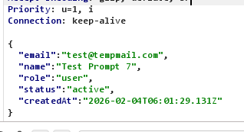

test@mailinator.com public inbox provider

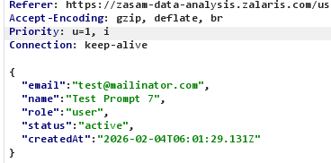

test@10minutemail.com temporary Mailbox

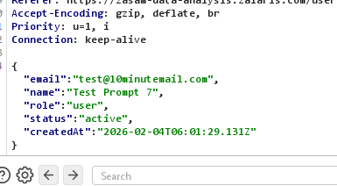

test@fakeinbox.com - anonymous email Provider

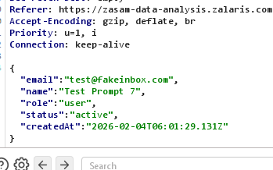

Arbitrary File upload

Test1 - File extension change - json to exe

Test Passed - application rejects the file

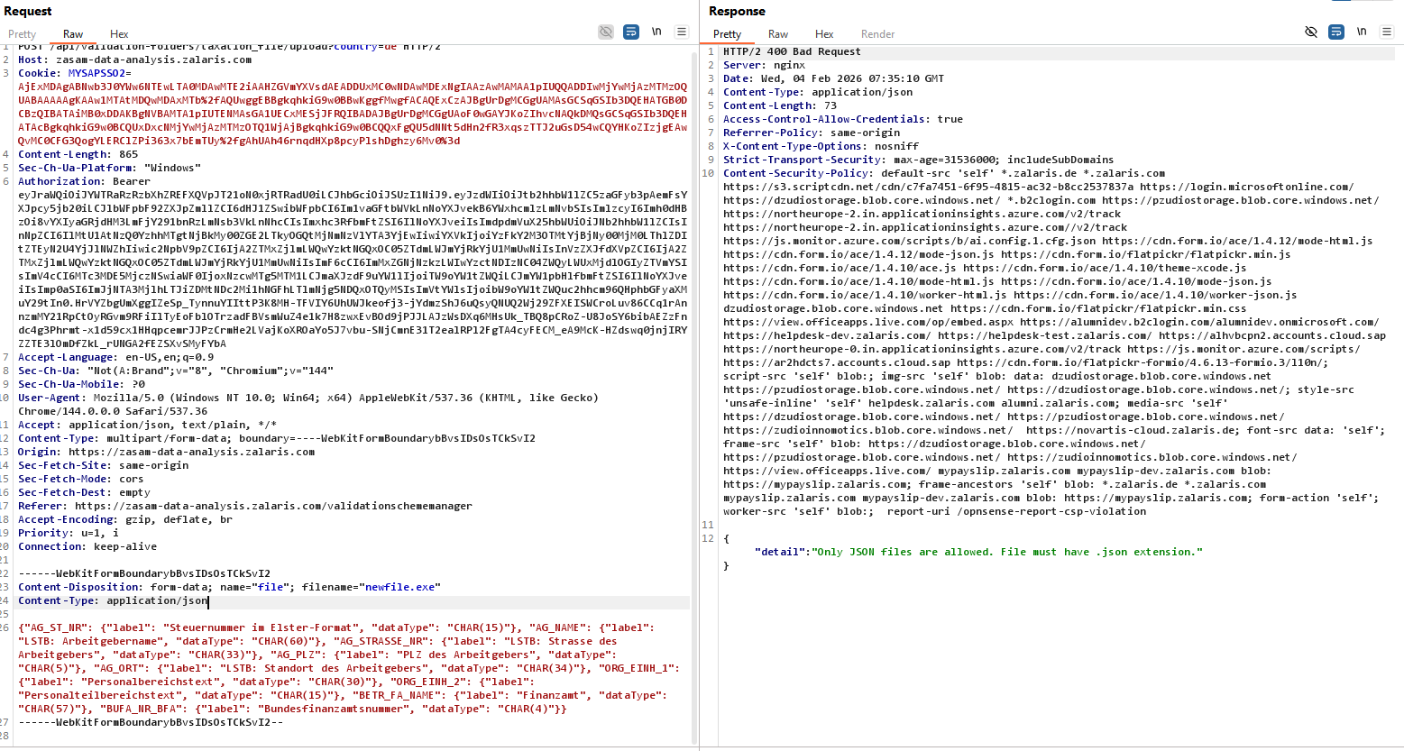

Separate File with special characters -
Test Passed - special characters are not accepted by the filename

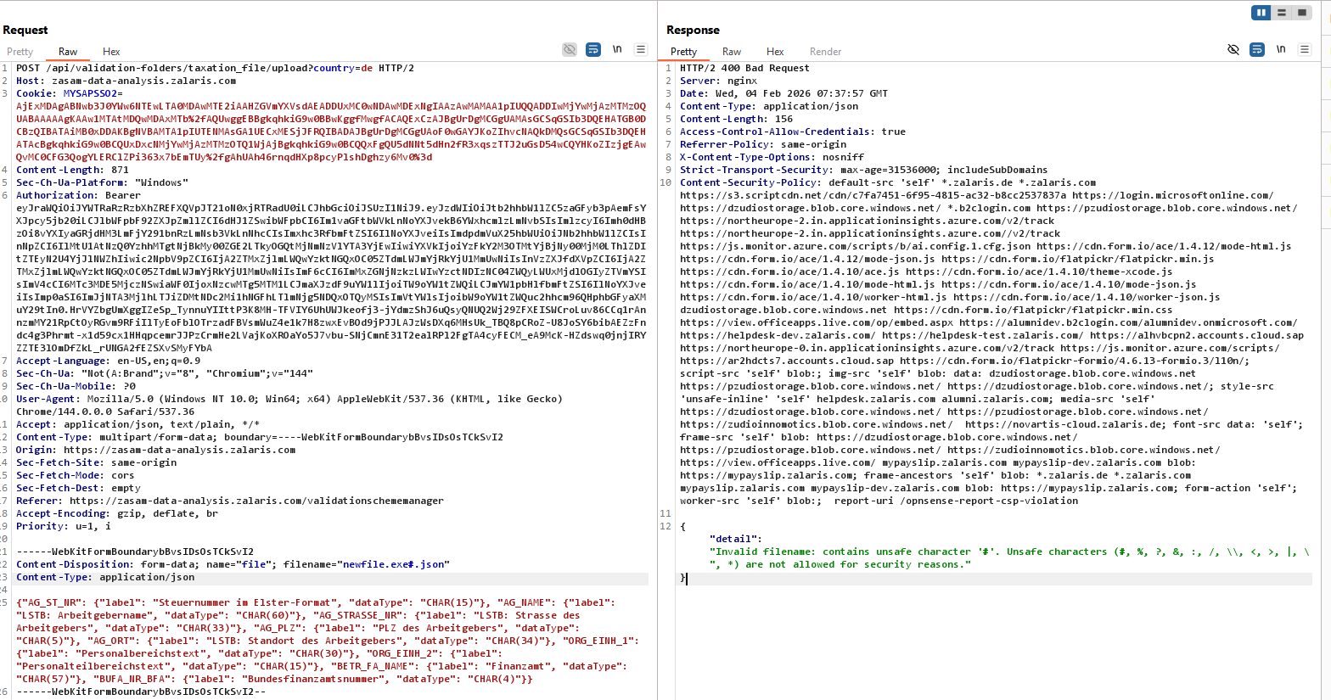

Still application only validates the list of the special characters given in the server response

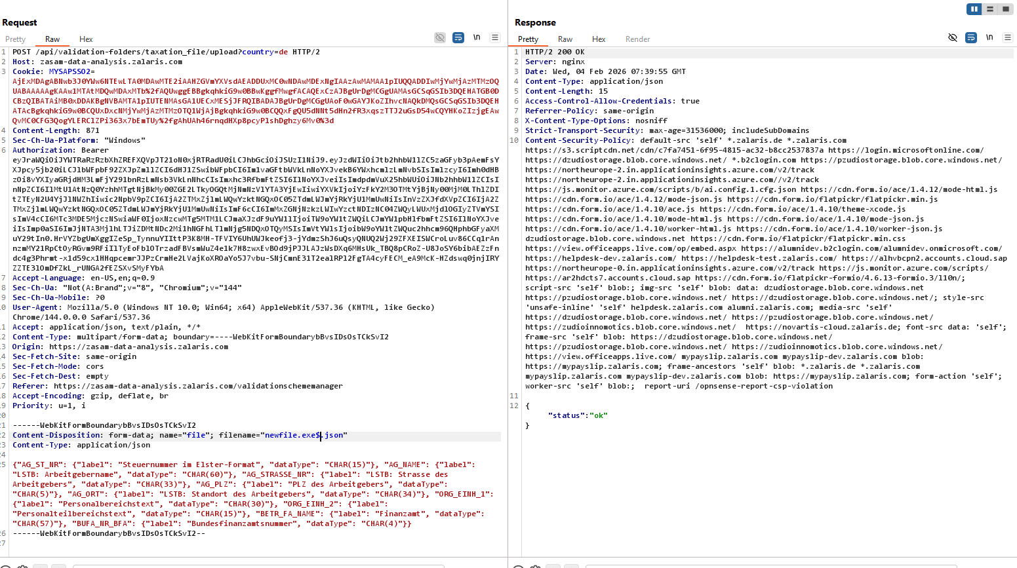

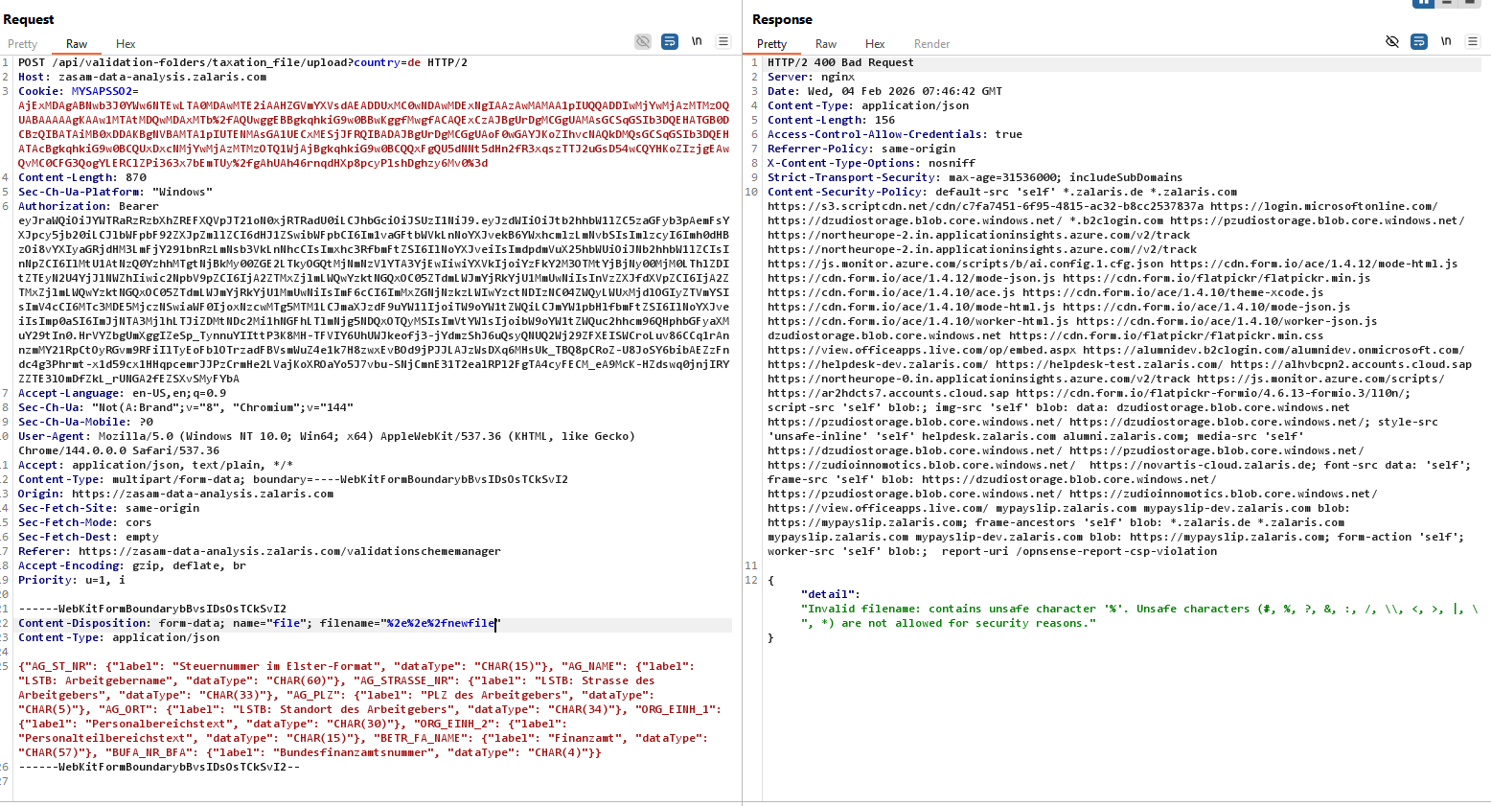

The path traversal characters are not allowed by the application

Normal special characters and encoded special characters are not accepted by the application

The path Traversal issue is mitigated

The file type and content typ are validated and Arbitrary File upload is not possible

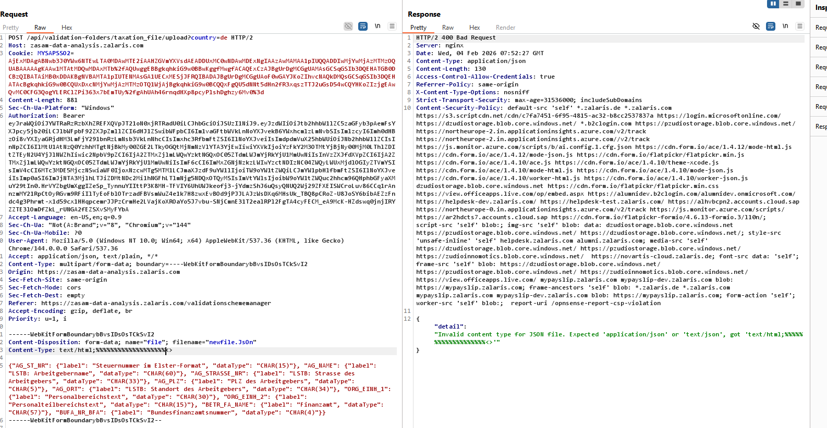

But the application does one thing it reflects the user input in alert box and check for injection in here

RBAC Test

Allowed Roles

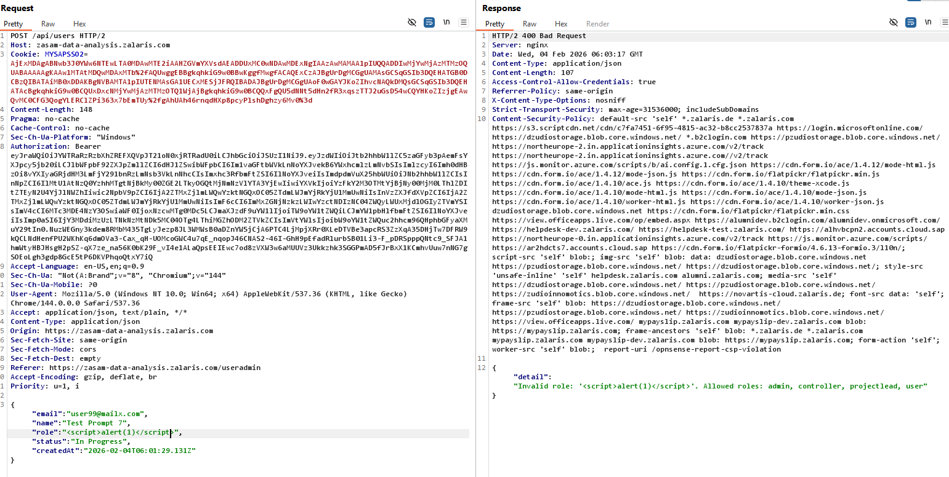

Allowed status

